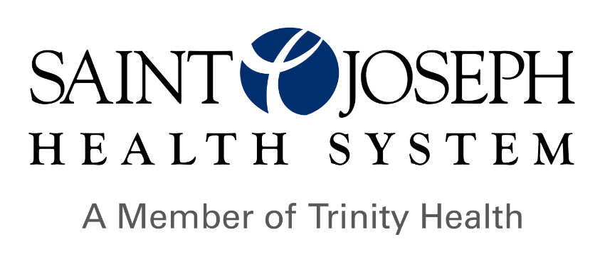

**Financial Assistance:** Trinity Health is committed to providing care, treatment and services to all who come to us based on medical necessity.

*Review Federal Poverty Level Guidelines here*

<https://aspe.hhs.gov/topics/poverty-economic-mobility/poverty-guidelines>]

***Financial Assistance Policy***

* Financial help is provided based on your income. This is defined using [Federal Poverty Level guidelines](https://aspe.hhs.gov/topics/poverty-economic-mobility/poverty-guidelines).
* If you earn [200]% or less of the Federal Poverty Level guidelines you can get a full discount. It applies to medically necessary services.
* If you earn between [201]% and [400]% of the Federal Poverty Level you may get a partial discount.
* Trinity Health will not charge qualifying patients more than the Medicare discount rate.
* Your copays, coinsurance, and deductibles may get discounts. You can qualify for aid if you earn less than [400]% of the Federal Poverty Level.
* If you are facing catastrophic costs, you may get discounts. This occurs when your medical expenses for the past 12 months are over 20% of your household income. The discount may also include the your copays. It can also include coinsurance, and deductibles.

Elective services such as cosmetic surgery are not eligible for financial assistance.

To apply for financial assistance, complete and submit the application. The Trinity Health Financial Assistance Policy and Application are available on the hospital’s webpage [Financial Assistance | Saint Joseph Health System (sjmed.com)](https://www.sjmed.com/patients-visitors/billing-and-assistance/financial-assistance). You may also request a free copy of the policy and application by visiting, mailing or calling the place you received care or by contacting Trinity Health Enterprise Patient Financial Services, 20555 Victor Parkway, Livonia, MI 48152, toll free at 800-494-5797.

The Trinity Health Financial Assistance Policy, Application, and Plain Language Summary are translated into other languages and are available by contacting the hospital or Patient Financial Services department listed above.

***Provider List:*** A list of Providers delivering emergency or medically necessary care in the hospital facility, who are covered by the hospital’s Financial Assistance Policy, is available online or upon request.

***Short-Term and Long-Term Payment Plans:*** If you cannot pay your share you may qualify for short or long-term payment plans. Trinity Health’s short-term payment plan is interest free. Patients must pay balances within one year. You may get a long-term interest-bearing plan if you can’t pay the total balance within one year.

***Patient Financial Services:*** Financial counselors are available to help you. They will assist you in completing financial assistance applications. This will determine what aid is available. This includes assessing eligibility for Medicaid.

You may contact a financial counselor at the place where you receive care. The financial counselor can help determine if you qualify for financial help. Financial counselors can also provide free copies of the Financial Assistance Policy, Application, and Plain Language Summary.